Communication and Behavioral Strengths
DISCstyles™ Report

Self-Awareness DISCovery Process

DISCover
and
Use Your Talents

Your Name: ___________________
Your Natural DISC Style: _____ Your Adapted DISC style: _____

The Self-Awareness DISCovery Process
Understand the DISC concept while DISCovering Yourself Through Your DISCstyles™ Report
Speaking the Same Language: A common theory on how communication makes a positive impact on your relationships; Personal, Professional, and Social.
The key to understanding yourself and others is a common format for identifying and understanding each person’s observable reactions, responses, personal strengths and communication preferences. There are many ways you can classify people through observation to identify what “type” of person they are. One of the most common theories addressing styles of communicating is the theory of DISC. Derived from the early work of William M. Marston, the DISC concept is used in a number of different ways to better understand, appreciate and adapt to people.
In relationship building, utilizing the DISC concept helps you to truly understand yourself. It also helps you understand how and why others are different and it helps you realize and appreciate the strengths of the different styles.
Remember, communication is more than what someone says. In fact, communication is more about what people do, or how they act. DISC considers all aspects of communication, from the words we use to how body language affects communication. By providing a common language with which to speak about our differences, DISC allows us to recognize other “types” of people, understand them better and leverage their strengths. Imagine the possibilities if everyone learned to appreciate the differences in others and understood the strengths the different styles bring to a relationship.
An important element of this process is to help you acknowledge the talents you know you have and discover the talents you may not have known you have. In addition, this process will help you find new ways or words to use when talking about yourself to others. This process will also help you to relate more effectively with others. The better you understand yourself, the better you will be at getting what you want. In fact, what you don’t know about yourself could keep you from getting what you want.
What you are about to experience is a process that will give you priceless insight into yourself. This insight will help you to know when and where to use your talents. Knowing this information will become very valuable to you.
The first phase begins with your assessment.
You will need the following to begin:
- Your report from your assessment
- A highlighter
- A pen
After completing your assessment and receiving your results, read your entire report. Highlight the statements you feel are true and underline the statements that may not be true.
Now, follow the instructions for the Self-Awareness DISCovery Process.

Self-Awareness is crucial to great relationships and to living an empowered life. It includes understanding how your approach influences others, and how to consciously use your strengths and to close development gaps.
Our goal is to help you understand your DISCstyles Report. Your responses to the assessment were scored and your report was generated providing information, feedback, and insight about you in terms of your behaviors and communication style.
There are several sections to your behavioral report and you’ll want to be sure that you understand each part. Getting and understanding the information will allow you to use your results to increase self-awareness and motivation. You’ll want to be able to name and claim your communication and style strengths so that you can leverage them.
Often times, because our strengths are so natural to us, we take them for granted and forget to consciously use them, or we can do the opposite. Without meaning to, we our strengths with no sensitivity as to how it may affect others, which results in conflict. These traits are so natural that we over play them and those very strengths can be perceived as our major weaknesses and the way some people describe us. Knowing these weaknesses are our personal and professional development opportunities. By becoming more aware of how our behaviors affect others, we can improve our own motivation AND strengthen our ability to communicate more effectively.
This process has helped many to be less judgmental about other’s differences, and has increased their ability to appreciate how differences make each person special and valuable. Set your goal for your report to make a positive difference for you as well.
It’s important to get a proper perspective on the reports in general, because of the specific aspects of you that are measured to produce your results. The assessment and report are tools for a deeper understanding about you. It is intended for you to apply the information as part of your personal and/or professional development process.
While there are numerous types of assessments, many people have come to learn the value derived from the type of report we are discussing, which is based on the DISC concept of understanding people’s styles. Your DISCstyles Behavioral and Communication Report, is one of the highest level of scientific validation, the easiest to understand, and most practical to apply in different environments; professionally, personally, and socially.
Behavior is known as the observable you; the characteristics that others see. Your report sheds insight into how you communicate with others, your personal behavioral style, and your usual approach to problems, people, pace, and procedures (or how you do what you do). Your behavior is not only observable, but it is adaptable or can be changed. In other words, behavior can be changed based on your perception of the demands of your environment.
There are, of course, other dimensions to the total you that go beyond your observable behavior. These other dimensions are not easily seen by others. One such area would be your motivators or the “why” you do what you do. These are your values; what you personally care about, what’s important to you – that which drives you to do what you do.
There is another dimension to a person, which is referred to as the person’s core abilities, aptitudes and skills. These skills are shaped by your education, experiences, and intelligence.
We have various tests, measurements, and assessments that are used to measure these other areas, and it is important to be reminded, for clarity, that we are now focusing on the area that is observable; the “how” you do what you do.
You will benefit from some very basic education about the concept of understanding behavioral styles, so before we dig into your personal report . . .
Let’s do a quick exercise . . . Look at the two lists below:

Slow-Paced
Passive
Reserved / Listener / Quiet Supportive / Thoughtful
Cautious / Methodical

Fast-Paced
Active
Assertive / Bold / Outgoing
Competitive
Spontaneous / Determined

Think about how you prefer to act most of the time.

Do you prefer the Slow-Paced list?
Passive, reserved, a listener rather than a talker, quiet, supportive,
cautious, careful and methodical. . .
Does that sound more like you most of the time?
Or do you prefer – the Fast-Paced list?
Active, assertive, bold, outgoing, competitive, spontaneous, determined. . .
Does that sound more like you most of the time?

It may be difficult to pick one list, but look at the lists and pick the list that is most like you now and/or most of the time.
Mentally make a note of the group you selected. Is it to the right or to the left of the bold vertical line?

Now, you get to pick again. There are two different descriptions or series of word choices.

Task-Oriented
people are more comfortable with "doing things" or working on projects rather than dealing with people. They make decisions independently, based on facts.

People-Oriented
people enjoy "being with people" more than dealing with projects. They are often seen as warm, caring, sensitive, and compassionate.

Are you more People-Oriented?
People focused, warm, caring, sensitive, and feeling.
Or are you more Task-Oriented?
Project (doing things) focused, logic focused, and questioning.
Again, it may be hard to choose, but pick the group that’s most like you most of the time. Make a mental note of the list you selected. Is it above or below the bold horizontal line?
Summarize your mental notes of where you plotted yourself. Above the line and to the right? Above the line and to the left? Below the line and to the right? Below the line and to the left?
In other words:
If you selected Fast-Paced and Task-Oriented, you are above and to the right of the bold lines. We call this the “D” style.
If you selected Fast-Paced and People-Oriented, you are below and to the right of the bold lines. We call this the “I” style.
If you selected Slow-Paced and People-Oriented, you are below and to the left of the bold lines. We call this the “S” style.
If you selected Slow-Paced and Task-Oriented you are above and to the left of the bold lines. We call this the “C” style.
Each list of basic preferences is combined to make up the concept of understanding people’s styles for which we use the letters D, I, S, and C.
This is referred to as the DISC concept. (Visual on next page)
The online assessment you completed accurately determined the intensity levels and the blending of the traits associated with this concept of D, I, S, and C in far more detail than this simplistic exercise you just completed. Hopefully, this exercise helped you understand the basic concept as a foundation for understanding intensity levels and blending of traits.

The visual below will show the positioning with four DISC quadrants:
The "D" style is Fast-Paced and Task-Oriented
The "I" style is Fast-Paced and People-Oriented
The "C" style is Slow-Paced and Task-Oriented
The "S" style is Slow-Paced and People-Oriented
Decisive, Task & Fast-Paced
Active / Assertive
Confident / Bold / Decisive
Competitive / Determined
Spontaneous

Steady & Slow-Paced
Supportive / Thoughtful
Calm
Methodical / Steady
Sentimental / Shy

Careful, Task & Slow-Paced
Questioning
Logical
Skeptical / Challenging
Data Driven / Perfectionist

Inspiring, People & Fast-Paced
Persuasive / Influential
Verbal / Relational / Social
Enthusiastic / Demonstrative
Agreeable

•If you chose Decisive & Fast-Paced - you might have high D, dominance preferences.
•If you chose Inspiring & People-oriented - you might have high I, influence preferences.
•If you chose Steady & Slow-paced - you might have high S, steadiness preferences.
•If you chose Careful & Task-Oriented - you might have high C, compliance preferences.
Notice how each corner represents a set of communication descriptors.
D
S
C
I

Now that you have the concept, you deserve to know that the DISC language and assessment process has been used by more than 40 million people to provide a common, non-judgmental language for discussing style preferences, and helps us to better understand how our behavior can impact others.
Let’s look at some of the behavioral preferences of each style.
D - direct, assertive, control, expresses anger with ease, get it done attitude, action-oriented
I - talkative, expressive, warmth, optimistic, persuasive, influential
S - warmth, kind, easy, harmony-makers, family-oriented, resistant, systematic
C - objective, neat, analytical, fact-finder, data driven, perfectionist
Now, let’s check out your style as it’s explained by your report.
Turn to the page in your report with the graphs as you see below:
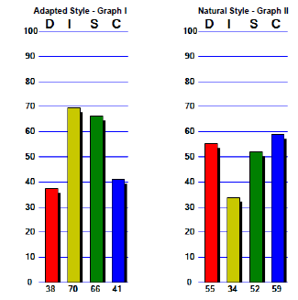
example

Above each graph, notice the DISC letters across the top.
Notice the 0-100 on the left sides, and the red, yellow, green and blue bars. This bar graph indicates your actual scores (intensity levels) for the D, I, S, and C columns.
Note: The midpoint is indicated at the 50-point line.
Circle your natural graph, the graph on the right. This graph displays your preferred style.
Preferred style means that if you had your choice, you’d prefer to act and behave in this manner. It is the style that is most natural and comfortable for you.
All the areas above the 50-point line are considered high areas. The closer to the 100-line, the stronger the tendencies.
What areas are above the 50 midpoint for you? The highest area is your primary style, the second highest is your secondary style. And if you have another area above 50, that would also be part of your style.
Please Note: Your intensity level scores are not a part of a contest to see if you are the highest or lowest, it is insight into your preferences. Each plotting point’s level has its strengths. Each also has its own potential weaknesses and areas for improvement. It is the awareness you have of your style and how you use it that is important.
Now look at the graph on the left, which is labeled Adapted Style.
An adapted style is how you are modifying/adapting/masking your natural behaviors.
example

The adapted style tends to change and may do so each time you take an assessment. It will change based on your perception of the demands of your current environment. So if you take the assessment again and your current environment changes from another time you took an assessment, your graph bars may differ.
Your natural style tends to stay the same over time. Your natural style is who you really are.
As you compare your natural D, I, S, and C points with your adapted plotting points, calculate the difference mathematically. If there’s a 20-point difference between your natural and adapted, it could represent stress. You will have to determine if that is true for you or not. For example:
If there is a significant difference in your D between your natural and adapted style, you would ask yourself if you are holding back your assertiveness when your adapted style is a lower D.
If you have a significant difference in your I style, for instance, with your I higher in your adapted style, ask yourself if your environment demands you to be more verbal than you naturally prefer.
What about the S differences? Are you expected to be less methodical and more spontaneous? Any differences in your C levels could mean you are not expected to be so analytical or maybe more data driven.
The two graphs visually display if you are exhibiting your natural or most comfortable style preferences, or if you are masking who you are.
Masking one’s style could mean stress, as you may be trying to fit in by conforming, trying to be all things to all people, or perhaps that you can’t even identify exactly what you should be doing to satisfy the demands of the environment.
Go to the WORD SKETCH: Natural Style page with descriptive words.
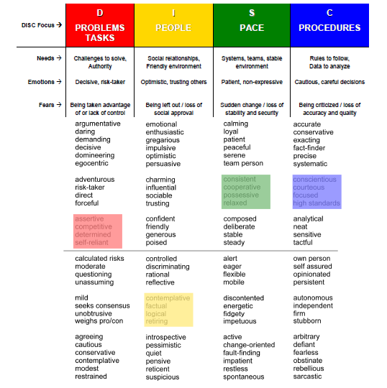
This page mirrors your natural graph. In other words, the placements of your bar graphs are now plotted with words instead of with the numbers that you saw on the graph page.

EXAMPLE

Do you see how the red, yellow, green and blue portions match the levels from your natural style graph for each of the D, I, S, and C columns?
If you look at the descriptors for the D, starting at the bottom, it describes preferences and behaviors of someone with a low D style - Unobtrusive, Peaceful, Modest, and Agreeable. All descriptors that are the opposite of a high D style are below the midline.
As you move up the list, you see how the intensity increases. Use this page to get a better understanding of what the report is saying about your strengths and development opportunities. This gives descriptive words to all the strengths you want to continue to leverage.
For the development opportunities, look at some of the words that are not as positive by definition. These are what we will refer to as potential weaknesses; negative descriptors for which you need to be aware. Can you see that you can be too demanding, too expressive, not cover all the details as thoroughly as needed, etc.? Of course, your descriptors probably differ from our example here, so refer to your report of your own descriptive words.
With this awareness, you can focus on putting yourself in situations (jobs, teams, and relationships) that ensure you get to use your strengths - because those are areas that are natural to you. You can also be more aware of when you are going to need extra assistance or when you should adapt your style to be more successful. Remember that when you need to adapt, it can result in stress.
Do you see strengths you were not aware of? Do you see development opportunities that could help you?
Do this same process with your WORD SKETCH: Adapted Style.
It is important as you review your adapted style, to remember the environment of your focus of concentration when you responded to your assessment: Did you focus on your Workplace, a Personal setting, or a Social environment?
Do you see development opportunities that could help you?
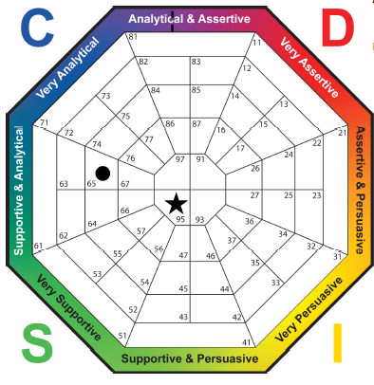
Now let’s look at the DISC DIAMOND in your report. This is another visual of your graphs…

EXAMPLE

Notice the letters D, I, S, and C around the diamond? The diamond shows how different styles intersect and the proximity of the styles.
In your report, the circle plotting point represents your Natural Style and the star represents your Adapted Style. The closer the plotting points are to the outer edge of the diamond, the stronger the tendencies and preferences are within that style segment.
If your circle is located closer toward the center, your style is less obvious to others and it may be easier for you to adapt to other styles. This is because you are actually tempering the strong tendencies by using some tendencies from the opposite side of the diamond. Remember that one is not better than the other - it is your awareness and ability to flex and adapt your approach to meet each situation that is important.
If there is a large gap between your Adapted and Natural styles, you will want to put some meaning as to why. Remembering that it may represent stress, as you are having to apply traits outside of your comfort zone in the environmental focus.

The diamond is displayed below with descriptive words associated with each segment.
Take a look at where your natural circle and adapted star are located on your report.
Make a note of the descriptors next to your circle and star.
Notice the differences in the descriptors across the diamond. (on the opposite sides)
For example: The D style vs. the S style and the I style vs. the C style.
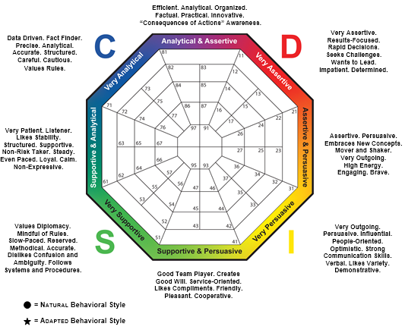

Imagine being given the opportunity to compare your report with another person’s report and you begin to look at the plotting points of your natural style and that of the other person; consider the scenario that the plotting points are positioned on the diamond in opposite positions. The scenario is one that demonstrates two people that may have a very difficult time getting along.
But if you and the other person are aware of this concept, you can both figure out how to appreciate the differences – the opposite styles – you can both thrive and truly get great results together by each person using his/her own strengths while augmenting the potential weaknesses of the other. This process is the appreciation of the strengths of the each other, being sensitive and accepting of the each other’s potential weaknesses.

Find the Communication Plans. These pages have four sections.
Each section contains characteristics of a style and how you may need to react and respond for effective communication. Use these pages to help you understand your style and how to adapt.
Another part of the report that will probably make more sense to you now is the Natural and Adapted comparisons. This part of the report provides verbiage specific to you on your natural and adapted approach to problems, people, pace, and procedures.
Your D style is your approach to problems and challenges
Your I style is your approach to people
Your S style is how you react to the pace of your environment
Your C style is how you react to policies and procedures
This part of the report can help you determine if the differences between your natural and adapted approach are causing additional stress for you.
You have gone through key aspects of your report. It is now recommended that you re-read your report. Check things you agree with, X the things you do not agree with, and put a question mark by the areas you are not sure about. Ask someone you know and trust to give you feedback about the areas you have marked. You may find that those things you disagreed with are really perceived as your traits. These may be “blind spots,” which are traits we are not aware of or have not realized. Use this additional feedback to help you gain even more insight.
You will find worksheets within your report. Take some time to list your strengths and development opportunities. Think about the impact of taking action and how you would benefit. And lastly, set a date with yourself to review how you are progressing.
Plan to re-read your report again and again over time. Each time you read it, you may see something that you missed in the previous reading. Additionally, the content may have more meaning for you.
Use the communication tips to change your approach and deepen your understanding of all the people in your world, including yourself.
The objectives for this process were to help you understand your personal style, tendencies, and ways that you react and respond; in other words, your observable behavior and communication traits. In addition, this learning experience is to help you improve how you communicate with others to develop effective relationships: including your job search strategy, your job interview process, and fitting in with a new team after job acquisition. Of course, it can also benefit you on the personal and social level.
Alternate versions of reports are available to go deeper into how to use the DISC information for career management, teambuilding, and even within the family environment. Remember, when the people in your world understand the DISC concept and apply that knowledge, your world becomes more cohesive and harmonious. Everyone “talks” the same DISC language. You can touch lives and make positive changes by referring your friends, family, co-workers, supervisors, team members and everyone to take their own DISC assessments and experience this process.
We will do our best to help and are always in support of your success!

